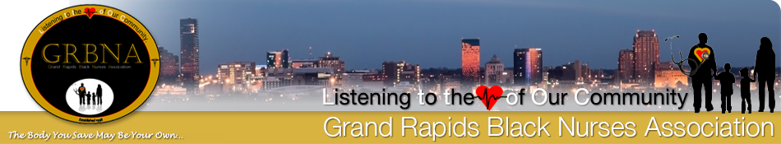
Dear Scholarship/Mentorship Applicant,
This Scholarship and Mentorship Program addresses Diversity Equity and Inclusion by integrating equitable opportunities to minority students to develop professional careers as nurses. It is our desire that this program will provide the encouragement and confidence to minority nursing students to pursue careers in workplaces where they are not commonly present.
The Michigan Annual Nurse Survey Project indicates that 5.5% of the RN workforce consists of Black Nurses. 2.3% of the RN workforce is Hispanic /Latino. 90% of the RN workforce is Caucasian.
According to the US Census, the population of African Americans in Grand Rapids is 13%. The IDEAS Nurse Mentorship Program seeks to create a nursing workforce that more accurately reflects the demographics of the population.
The goal of The IDEAS Nurse Mentorship Program is to address racial disparity in nursing through a Nurse Mentorship and Scholarship program, by providing financial assistance and professional development training for minority nursing students. The mission is to provide an opportunity to minority nursing students to complete nursing school successfully, pass the required state exam (NCLEX) and enter the workforce prepared; mentally, socially, and academically.
It is our hope and desire that providing mentorship and academic assistance will help to inspire nursing students, create diversity in the workplace, and to successfully mentor our candidates to become future healthcare professionals living in Grand Rapids.

Attached you will find the application to apply for the Grand Rapids Black Nurses Association (GRBNA) Scholarship.

To apply for these scholarships, students must:
- Plan to attend/be enrolled for the final 2 terms of a registered nursing program at an accredited college, university, or community college, in the upcoming academic year
- Applicants must provide a letter of acceptance into a nursing program or current transcript.
- Maintain/Have a GPA of 2.0 or higher
- Be a U.S. citizen or permanent resident, or legally able to attend school in the US
- The student must NOT be currently licensed as a registered nurse.
Each scholarship is awarded for up to two terms, and are currently based on academic pursuance at an accredited program as follows:
RN/BSN $2,500 per student, per academic term, for two academic terms ($5,000 total).

Mentorship Requirements:
- Attend professional development workshops.
- Complete practice NCLEX RN exams
- Communicate with an assigned mentor at regularly scheduled intervals.
- Complete a professional Resume.
- Report official academic progress at regular intervals.
- Express an interest in working in a hospital setting.

How to Apply:
- Complete attached application
- Submit an essay that addresses how you will advocate for diversity, equity, and inclusion in your professional practice. Please explain how you will use your role as an RN to mentor other minority nurses and nursing students.
- Submit required documents to GRBNA at grandrapidsbna@gmail.com
- The required documents must be in legible PDF or Word Document format.
Notification of award will be issued by e-mail/ phone.
Monies will be paid directly to the school.
Questions may be sent via email to Scholarship Committee at: grandrapidsbna@gmail.com

